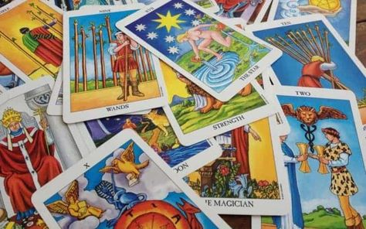
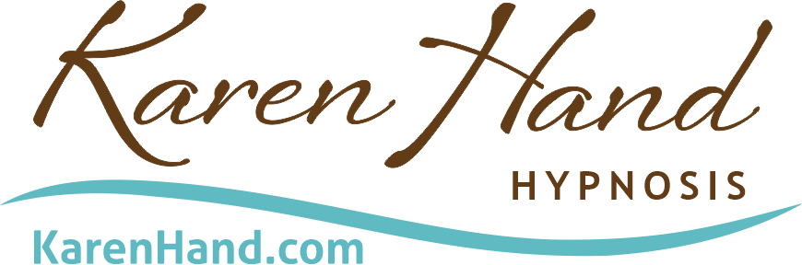

Tarot Suit and Numbers
Thought Provokers
Based on Shawn Carson’s Tarot for Personal Evolution

MINOR ARCANA ‘PIP’
Swords – Mind, thoughts, learnings
Cups – Heart, Emotions, Motivation
Wands – Gut, Drive, Courage, Energy, Creativity
Pentacles – Body, Time, Money, Action

Ace – Source, origin, divine, inspiration
Two – Decision, discernment, distinction
Three – Creation, representation, archetype
Four – Value, nature, construction
Five – Belief, limitation, struggle
Six – Heart of, unconscious, inner wisdom
Seven – Feelings, emotions, fear, confidence
Eight – Thoughts, images, self-talk, echo
Nine - Dream, model, map
Ten – Realization, completion, reality

THE COURT
Page – Learning, studying
Knight – Applying
Queen – Female/Yin Mastery
King – Male/Yang Mastery

312-315-2100
Karen@KarenHand.com
© 2023 Karen Hand Hypnosis, Chicago LLC www.karenhand.com

